AI WHISPERER


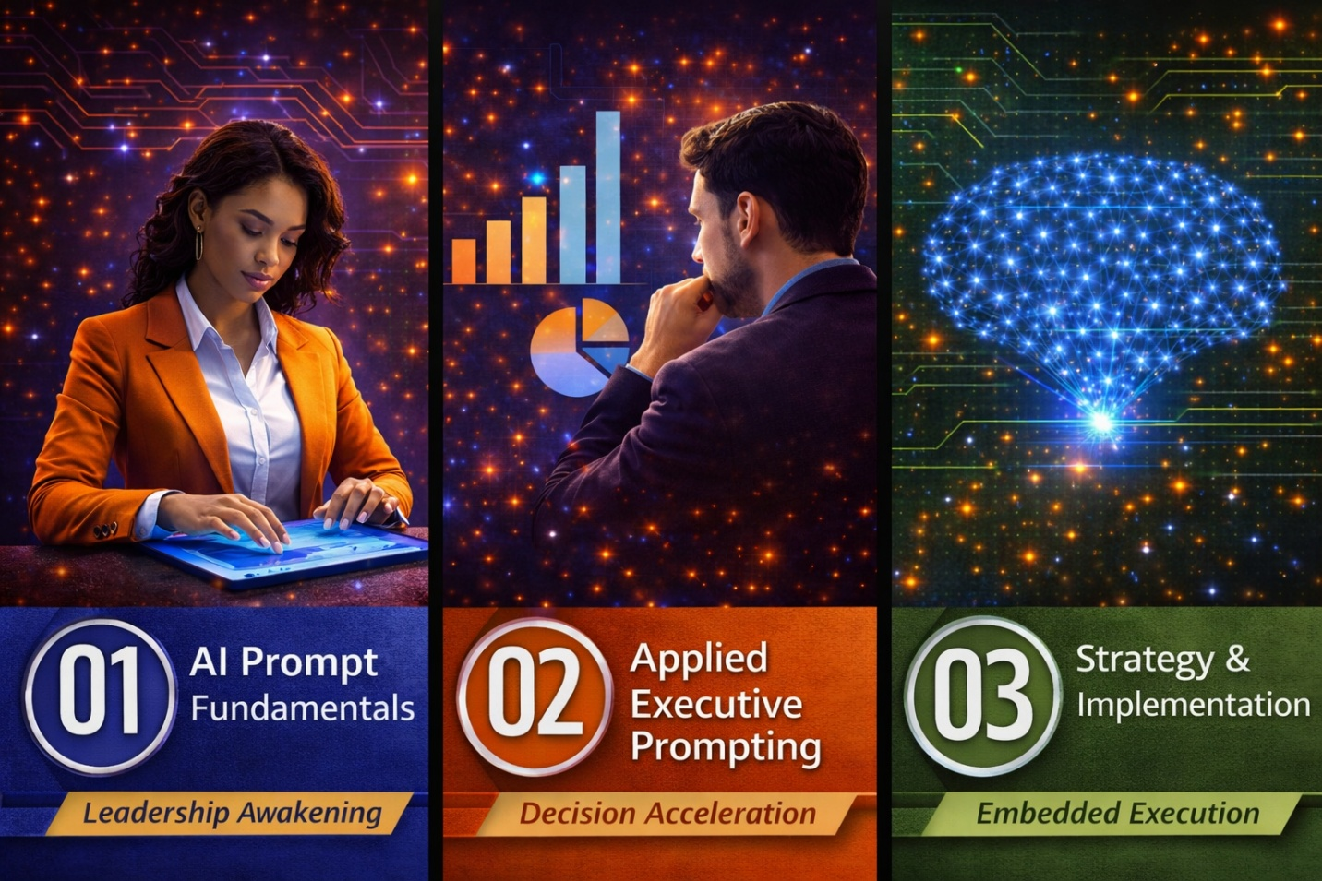

EXECUTIVE/ BUSINESS FOUNDER PERSONALITY PROMPT
Analyze the attached image of an OCEAN (Big Five) personality profile for an established business founder or executive. The trait scores are:
- Openness: [put in score]
- Conscientiousness: [put in score]
- Extraversion: [put in score]
- Agreeableness: [put in score]
- Neuroticism: [put in score]
The individual already owns a revenue-generating business and holds a leadership role. Based on this personality profile:
- Provide a casual, coaching-style analysis of this person’s executive strengths, blind spots, and leadership tendencies.
- Suggest an ideal strategic decision-making approach based on their personality — including how they likely approach problem-solving, innovation, and long-term planning.
- Recommend a marketing and branding style that aligns with their personality traits — including messaging tone, brand voice, communication platforms, and customer engagement strategy.
- Present a visual chart or markdown-style table that maps each of the five OCEAN traits to actionable insights across:
  - Leadership/Team Style
  - Strategic Thinking
  - Marketing/Communication Style
Tone: Keep the analysis grounded, conversational, and practical — as if a business coach were offering tailored insights to a seasoned founder looking to fine-tune their leadership and brand alignment.

